The Dloeeian Times
TOP NEWS:
DLOEE DECLARES THE ENEMY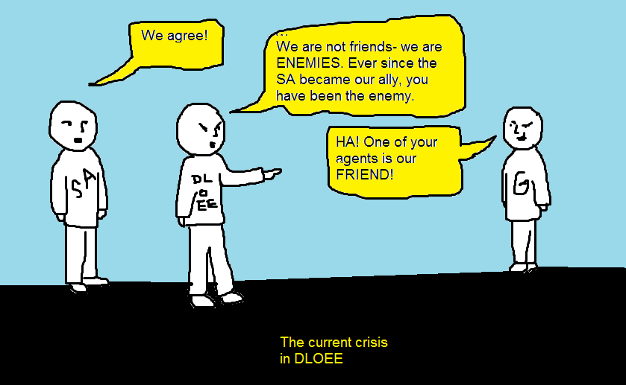
How, we ask ourselves, is the alliance between SA and DLOEE? Well, I can confidently say it is going well, as quite a few SA members are, or were, friends of DLOEE. Now that we are allies, there are no more break-time disputes; unfriendly conversation or just plain hostility. However, while this alliance lasts, our only enemy is The G (TG): they are a group of incredibly annoying children who have nothing to do all day except chatting, which annoys DLOEE members who sit next to them. Will we EVER have a moment’s peace??? Looks like we never will. Consequently, we decided to declare them the NEW ENEMY. That’s great, you are probably thinking: it would have been, if there wasn’t one tiny flaw (CONTINUED ON PAGE 2)
Interested in this news? Tell us via the website dloeehq.yolasite.com (send us your email address and what you want to know on the ‘Contact us’ page!).

May 29th, 2013

THIS FORTNIGHT’S ARTICLE:
PAGE 1: TOP NEWS & PICTURES
PAGE 2: MORE ON THE DLOEE CRISIS WITH TG
PAGE 3: HOW MUCH DO YOU KNOW ABOUT DLOEE?
PAGE 4: ANSWERS TO PAGE 3
PAGE 5: ADVERTISEMENTS, ANNOUNCEMENTS
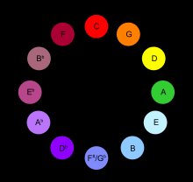
Music lovers/ painters, rejoice. The colour circle of music is here! Select your favorite color and see which note it is! Compose note sequences using this awesome circle.

My strange, modern impression of… Some boulders and a grassy field.

CONTINUED TOP NEWS
which is that a DLOEE member is actually FRIENDS with the TG! In fact, she doesn’t hang out with us anymore, she hangs out with TG! She even said to us the other day: “I don’t like playing running games as much as singing and dancing and stuff. You’re always playing running games and everything, and because I don’t like them, I play with TG. If you played something else apart from running games, I would play with you.” The cheek! To say that! Of course we play running games; you never know, one day it could save your life if you build up your stamina and speed. However, it is nearly impossible that singing and dancing routines could save your life. That is the reason why we are always running. Moreover, when we rescued a TG from the clutches of a bully, they were so ungrateful they didn’t even THANK us. An “oh, thanks very much for saving her” or a “thank you, I don’t know what we’d do without you” would have been nice.
I am confused. I am perplexed. I am befuddled. I am baffled. I am mystified. There is no other word for it; why doesn’t this rebellious DLOEE member just turn around and hand in her resignation form?
On a lighter note, DLOEE definitely owns the market today (in terms of reputation). TG definitely doesn’t. I think it is because DLOEE puts their brains to good use. This is a typical conversation between two TGs:
TG 1: Did you know what he said about her?
TG 2: OMG, what???
TG 1: (Whispers something about love)
TG 2: Oh gosh, don’t let him know about that, or they’ll be fighting over her!
TG 1: I know right, (breaks out laughing) should I tell everybody else?
TG 2: Nah…
TG 1: Do you like One Direction?
TG 2: Yeah, I love them! Have you heard…?
TG1: Yeah… I really like the lyrics.
TG 2: I’ve got the song stuck in my head! (Sings or hums)
And on, and on! Here is a conversation between DLOEE members:
DLOEE 1: Those TG are SOOOO annoying!
DLOEE 2: Makes me want to take action. We’ve watched them chatting for so long.
DLOEE 1: Let’s bomb them! With a stink bomb! Or let’s sneak 10-day-old cowbird egg shells into their desk! Or even-
DLOEE 2: Shhh, be quiet. We’ll put a stink bomb in their desk. How does sulphur sound?
DLOEE 1: Where do we get the sulphur?
DLOEE 2: Duh, from a science department…?
DLOEE 1: OK. I’ll bring the capsule and the self-detonating machine.
DLOEE 2: Let’s get the whole league on this project: plan TG Bomb!
DLOEE 1: Great, but we’ll have to stay undercover.
DLOEE 2: Make sure when you launch the bomb you angle it at precisely 51°, and that you use level 4.5 force.
DLOEE 1: Got it. Where’s the bomb catapult again?
DLOEE 2: SA had it. Get from them, and say it’s urgent!
Can you see the difference?

HOW MUCH DO YOU KNOW ABOUT DLOEE?

Take this quiz and find out!

- Can you name all of DLOEE’s allies?
- What does the DLOEE symbol look like?
- What did the SA call themselves before making peace with DLOEE?
- When did the DLOEE era begin?
- Which teacher was an inspiration for DLOEE?
- What is/are DLOEE’s website(s) called?
- Name one TG.
- Name four DLOEE members.
- Name DLOEE’s favorite online game.
Check your answers on the next page!

Hint for one question:


Answers:
1. Destroyers and SA
2.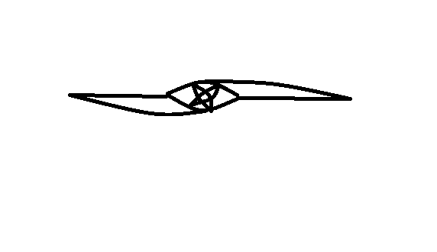
3. T*lib*n
4.2012
5. Mr. Hardeman
6. dloee.yolasite.com and dloeehq.yolasite.com
7. Chloe, Kaia, Eva, Tiana…
8. 4 out of: Shing Ho, Aman, Sanjeev, Rohan, Lauren, Alyssia, Kaia, Aidan, Tiger, Marbles, Beachball
9. poptropica.com

* stands for ‘A’
Would you like to put an announcement here? No probs, just write your full name, email address and message/announcement at:
http://dloeehq.yolasite.com/contact-us.php

BEETHOVEN VS VIVALDI- who will win?
Beethoven or Vivaldi?
- Beethoven
- Vivaldi
- Don't know!

The school year is almost over! Spend some quality time with friends, before secondary school.
Do you think you could write for The Dloeeian Times? Tell us via:
http://dloeehq.yolasite.com/contact-us.php

