- The Dloeeian Times
July 11th, 2013
NEW F.I.S.T EXAMS CAUSE UPROAR
‘Have you passed your FIST?’ is the first question a DLOEE agent will ask you if you approach them. Well, for those of you who don’t know, F.I.S.T stands for: Fighting, Intelligence, Strategy and Tactics. On passing their F.I.S.T, DLOEE agents are promoted, and given a badge on an appointed date. Be forewarned: the FIST is harder than it seems! Agents need to go through a gruelling week of preparation, then another gruelling week of the actual examination! Fighting—is pretty simple- a DLOEE administrator will choose a suitable opponent, and whoever wins (forces the opposition to cross a certain line) passes the test. Meanwhile, the not-so-victorious agent has to fight someone again. Intelligence—is EXTREMELY difficult the first time (if you fail first time the test will be easier the second time). An agent will be handed a test paper. They must fill it in within 15 minutes. These questions are very challenging, pushing most intelligent agents to their limits. Here is a sample question:
Factorize:
$$a^{2}-b^{2}$$
Strategy is connected to Tactics. For Strategy, all you do is formulate a plan and carry it out; if it works, you pass! In the Tactics exam, you must pair up with an agent who is as skilled as you, and basically to the same as Strategy.
If you pass these exams, you get a nice badge with your initials and the DLOEE symbol in a colour of your choice!*
Cool enough, eh? Well still, some people found it hard.
“Why, oh why, do I need to pass some exam? I don’t wanna..!”
And some even threatened us…
“You’re fired.”
Still, this raises the question: “Are the DLOEE FIST exams too hard?”……continued on page 2
* providing it is available
Contents:
Page 1: TOP NEWS
Page 2: continued top news
Page 3:
SA needs to say something
Page 4:
Announcements and advertisements

HAVE YOU RECENTLY BEEN INJURED?
DON’T WORRY! CALL THE DLOEE INSURANCE COMPANY
Hopefully next year will be better. Which part of the exam is causing the problem? Should the Intelligence test become easier?
-u9 fefjijilkklKKL;kpmknkiojgojpl;]
Lhsorry, I let the cat loose on the computer.
THE BEST KNASERS YOU CAN GET! BUY YOUR MODEL X103 NOW!!! Only $999,999! Available in 3 colors: black, purple and green. 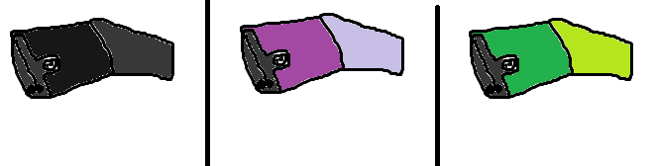


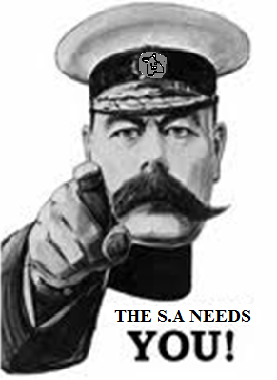
Interested in joining the SA? As commander Idean Zarandi put it, the Supreme Ally needs you! The SA is an ally of DLOEE (see last issue) but these two leagues used to be enemies and they had an interesting history (get the next issue). Lord Kitchener and Uncle Sam are shown in the propaganda.
Lord Kitchener (24 June 1850 – 5 June 1916) was a British Field Marshal and colonial administrator who won fame for his imperial campaigns and later played a central role in the early part of the First World War, although he died halfway through it.
Kitchener won fame in 1898 for winning the Battle of Omdurman and securing control of the Sudan, after which he was given the title "Lord Kitchener of Khartoum"; as Chief of Staff (1900–02) in the Second Boer War he played a key role in Lord Roberts' conquest of the Boer Republics, then succeeded Roberts as commander-in-chief.
Uncle Sam (initials U.S.) is a common national personification of the American government that, according to legend, came into use during the War of 1812 and was supposedly named for Samuel Wilson.

JOIN DLOEE OR ONE OF DLOEE’S ALLIES!
SEE THE WEBSITE FOR DETAILS
JOIN SA!
SEE IDEAN ZARANDI FOR DETAILS
REPORTS
COME OUT
JOIN THE DESTROYERS!
SEE THE WEBSITE FOR DETAILS
ON FRIDAY
POLL
Do you like carrots?
YES
NO
DEPENDS ON HOW THEY ARE COOKED
DO YOU WANT TO TAKE YOUR FIST EXAMS?
GO TO:
dloeehq.yolasite.com

